## **Reverse Fallacy**

*“A gambler decides, after a consistent tendency towards tails in the toss of a coin, that tail is a more likely outcome for the future tosses of the same coin”*

**Group 9**

**Cohort 2**

**AswathySaju**

**Dhruv Vig**

**SreeLakshmi**

**Srivats**

Contents

**1. INTRODUCTION** 3

**2. BUSINESS Description** 3

**3. FUNCTIONAL Description** 4

**4. FUTURE scope** 5

**5. WHY No-SQL Technology?** 6

**6.** **APPLICATION Screenshots** 7

**7. DESIGN Diagrams** 14

**8. DATABASE Layer** 19

**9. REFERENCES** 23

## **1. INTRODUCTION**

Tennis is definitely one of the most popular and cherished sports in many countries located all over the world. Betting on tennis is clearly something that millions of US, UK and other global residents enjoy on a regular occasion. Tennis reportedly ranks third behind horseracing and soccer among online bettors. The most anticipated match -Wimbledon final 2007 between Roger Federer and Rafael Nadal drew more than $60 million in wagers through one online betting website -betfair. This gives a bird’s eye view about the amount of money and interest that goes into tennis betting from around the world.

## **2. BUSINESS Description**

Betting is not just a sport but also a means to making easy money for many people in world. Our objective is to create a one-stop guide to make tennis betting enthusiast a well-informed decision regarding their bets. **Data loving gamblers bet on Tennis by the numbers and statistics** (Article). Professional gamblers and investment funds are using computer algorithm based on mathematical models to win money from bookmakers. A lot many people rely their betting on factors such as winning odds , player power ranking recommended by some of the top betting sites. A lot of information and data analytics goes into calculating these factors for a player or for a game.

1. **Player Head to Head statistics**

As a Tennis Bettor, one of the first things you check is Head to Head Stats. After all, if the players have met 3 times and your fancied player has won all three matches, surely that is a good sign.

1. **Betting Odds**

Odds reflect the probability a specific outcome in an event. There are mathematical algorithms that process the player statistics, surface, player form, power ranking etc. and calculate the odds of winning for a player. Betters rely on these odds to make their decision.

1. **Players Form**

The physical demands of the professional game these days means it’s almost certain that every player on tour will suffer some degree of injury during any given season, and knowing about these has a huge weighting on the odds

1. **Surface**

Tennis is one of the several major sports where players compete on different types of surfaces. Some players' games are much better suited for grass than hard courts.

1. **Player Power ranking**

A lot many people depend on the ATP ranking and some form of power ranking calculated to weigh and compare the winning chances of any player at a game. The ranking is based upon the performance of the player in all top matches he has played in the past.

## **3. FUNCTIONAL Description**

Our project is on creating a website that provides information and live data for betting on the most popular and current matches in tennis. The following are the business features we serve to address through our website.

**3.1 Provide statistics for the bettors to make informed betting decisions**

**3.1.1** Head to Head statistics

**3.1.2** Player Info

**3.2. Recommend the top betting websites based on user rating**

The most popular betting websites offer the winning odds for different betting types, which is another important factor that goes into betting decision. We recommend the top tennis websites to the user based on its popularity (average user rating).

**3.3 Live Betting Trends**

Live betting trends intends on capturing the trends of betting while the match is going on. Betting Trends shows the total number of bets placed by different users on a player for a particular match in the top 11 websites from starting time of the match against time. This curve also has the total bet money placed on a player at any point in time. For the scope of the project, the betting type is limited to Money Line betting on Match Result.

**3.3.1 Relevance of Betting Trends:**

* **For the Bettor**

While trying to place a bet on a player who could be a probable winner, having a glance at whom the rest of the world is rooting for might influence your decision. The odds of winning changes as the game proceeds, so does the betting trends.

* **Analytics on betting trends help find anomalies such as match fixing**

The Analytics on the betting trends for a match can show anomalies such as probable match fixing in a game. In 2007, Betfair (a U.K based betting website) staffers noticed an unusually large amount of money being bet on a match in Poland between Nikolay Davydenko and Martin Vassallo Arguello -- about $7 million, 10 times the typical amount for a contest of that caliber. Even stranger: Most of the money was riding on Arguello, a no name ranked around 70 spots below then No. 4-ranked Davydenko. In addition, the same money was coming from a handful of bettors. Betfairs took the unprecedented step of voiding all bets on the match.

## **4. FUTURE scope**

The object of the project was to create a one-stop guide to make tennis betting enthusiast a well-informed decision regarding their bets.

Currently the scope of the project includes player statistics, betting website details and the betting trends for the current games. However to make a comprehensive guide we need to include the following features in future:

* The project cover just covers betting on match results (win/loss). In future we could include need to cover different types of bets on match event such as betting on set scores.
* Currently we are rating the sites as per user ratings but in the future we would like to show the user the websites providing the best odds.
* On the Database level, we could distribute the date using sharding and therefore utilizing cluster advantages provided by NoSQL Database.

## **5. WHY No-SQL Technology?**

The application that we have developed demands for coping with the rapid increase in data and traffic. Keeping in mind the future scope of the application serving huge number of visitors and data, we believe the best technology to adopt will be NoSQL for the following reasons:

**5.1 Impedance Mismatch**

Impedance Mismatch is the difference between the relational model and the in-memory data structures. The relational data model organizes data into a structure of tables and rows, or more properly, relations and tuples. As a result, if you want to use a richer in-memory data structure, you have to translate it to a relational representation to store it on disk. Hence, the impedance mismatch—two different representations that require translation. Impedance mismatch has been much easier to deal with using NoSQL technology.

**5.2 Sharding**

One of the biggest advantages to NOSQL technology would be ease of sharding because of the clustering of data. This supports the horizontal scalability, which is a huge requirement for our application. This balances out the load equally among the different shards. When it comes to arranging the data on the nodes, several factors can help improve performance. If you know that most accesses of certain aggregates are from a particular physical location, you can place the data close to where it is being accessed.

**5.3 Volume, Variety and Velocity of Data**

One of the most obvious reasons for adopting NoSQL technology for our application is the volume of data and velocity at which it keeps growing every second. In future, we are expecting to handle more variety of data related to a user.

## **APPLICATION Screenshots**

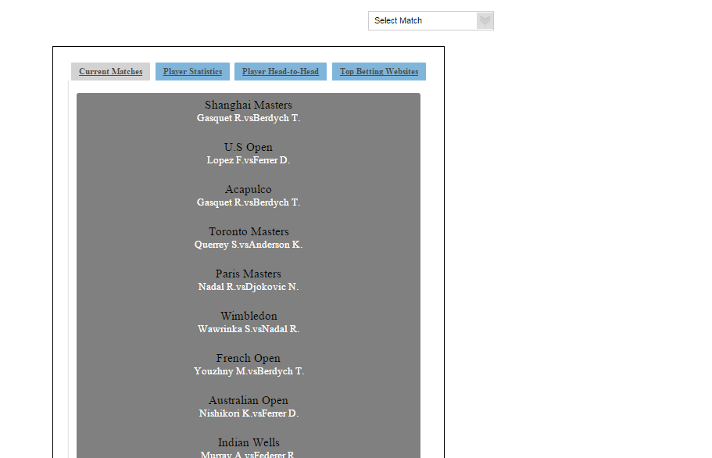

**Fig6.1.Home Page**

* Click on drop down for selecting from the current matches

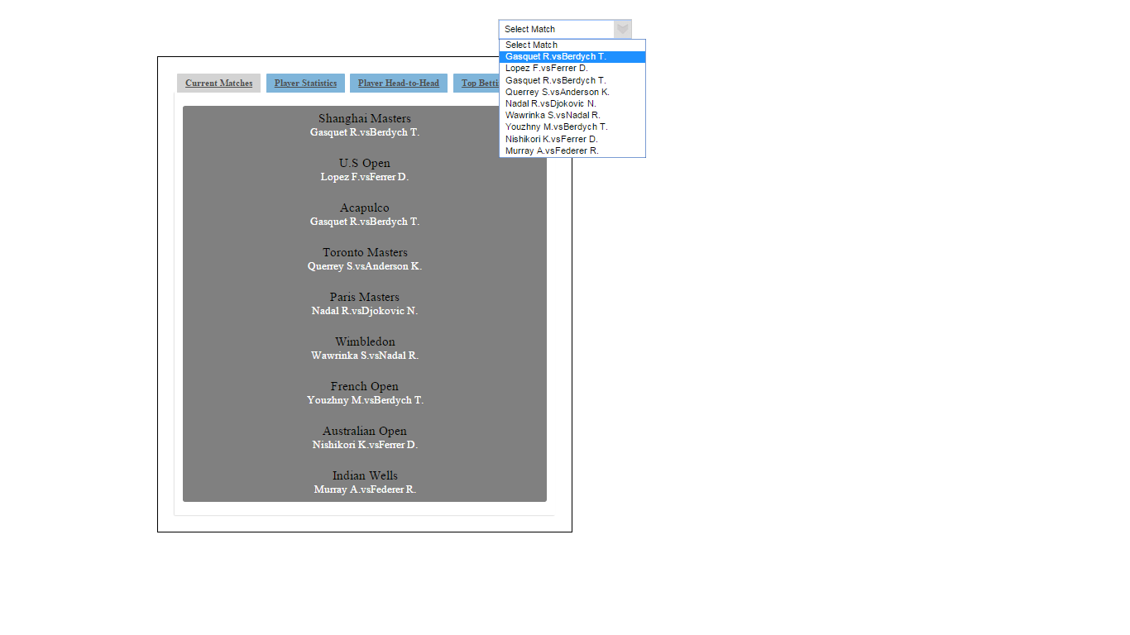

Fig 6.2 **the dropdown for current matches**

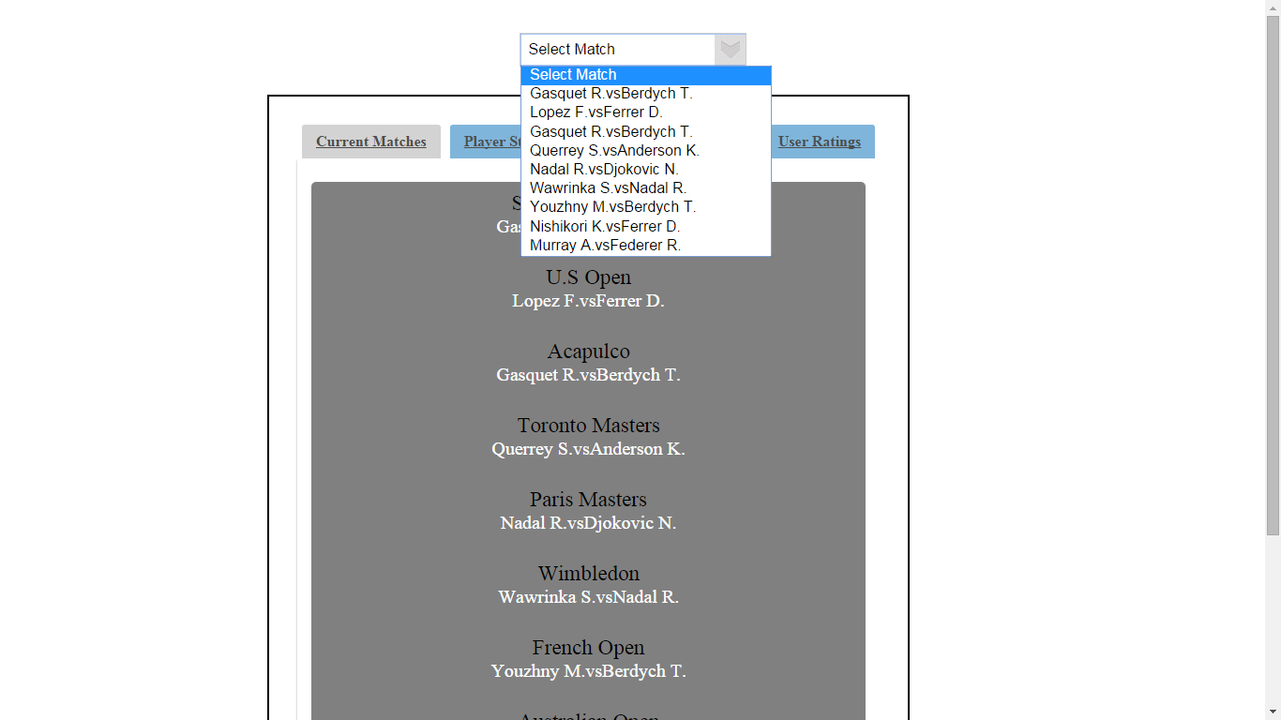

**Feature 1: Player statistics**

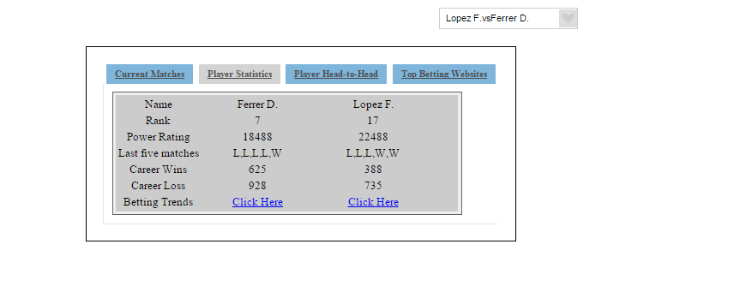

**Fig6.3 Player Statistics**

**Feature 2: Head-To-Head Statistics**

Click on Head-to-Head Tab to display the last five matches played by the two players.

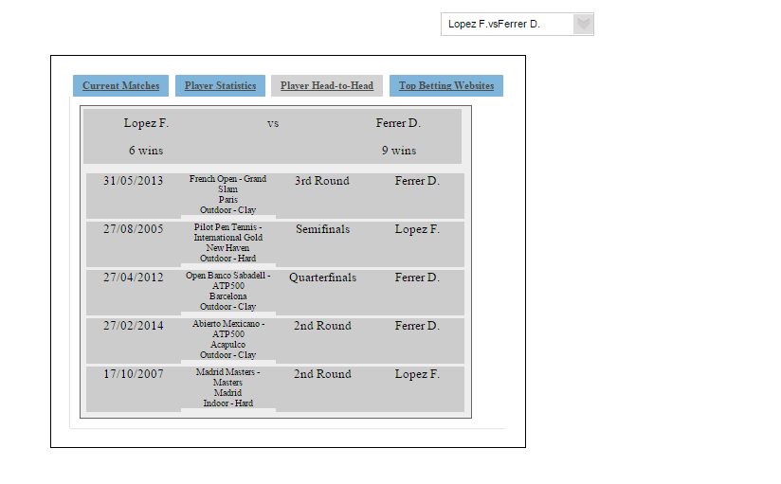

**Fig6.4 Head-to-Head statistics**

**Feature 3: Betting Trends**

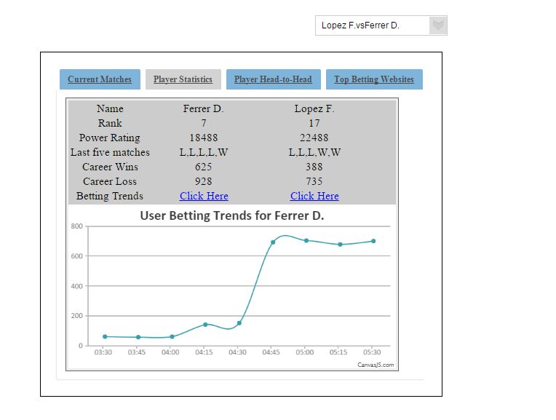

**Fig 6.5 Betting Trends for Ferrer D.**

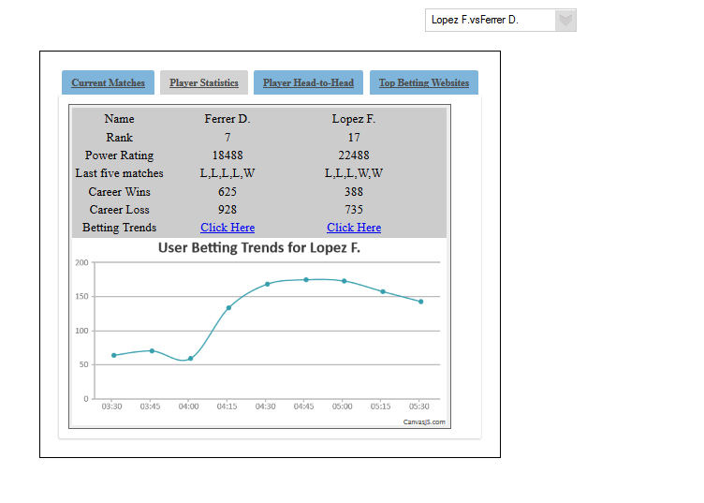

**Fig 6.5 Betting Trends for Lopez F.**

**Feature 4: Top Popular Betting websites based on User Rating**

Click on Top betting websites – to see the most popular five betting websites based on user rating

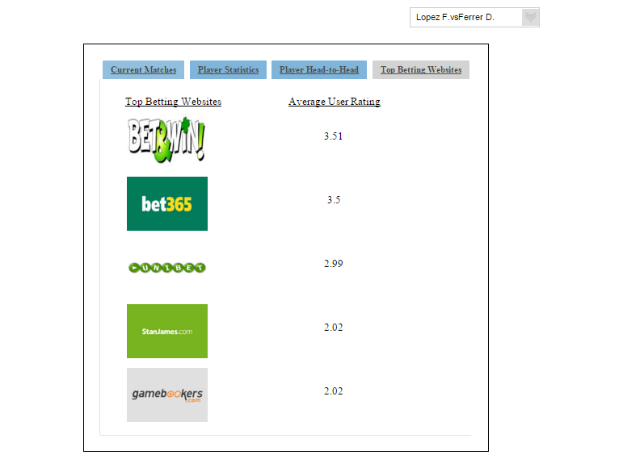

## **7. DESIGN Diagrams**

**7.1 Context Diagram**

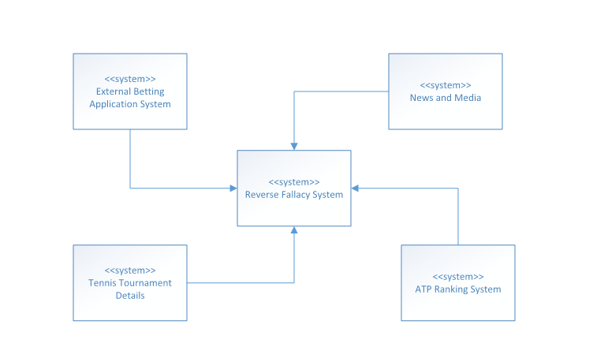

**The context diagram shows the interaction of our system (Reverse Fallacy) with the external systems/environments.**

1. External Betting Application System (External betting websites)

2. News and Media (Information of current betting trends for a match is of interest to news and Media)

3. Tennis Tournament Details (Information of all current Matches)

4. ATP Ranking System

**7.2 Architectural Diagram**



**Description:**

Reverse Fallacy system implements a Servlet architecture. Web browser or mobile browser is the User facing component of our application.

1. We have a local HTTP Server, Apache Tomcat 7.0, which connects with browser and servlet controller using HTTP protocol.

2. Servlet controller will call the business process connecting it with the NoSQL database, MongoDB in our case.

3. NoSQL will update data from externa betting website application.

**7.3 Use Case Diagram**



**Description:**

1. Actors: User and Reverse Fallacy System are the two actors, which interact with the system components.
2. Select Match: The first functionality lets the user choose the match for which the user would like to display the details.
3. View Player Details: Displays the details of the two players playing in a match.
4. View Head-to-Head Statistics: User can view the head-to-head statistics mainly based on the matches played.
5. View User Betting Trend: This key feature of our system helps the user understand the user the betting trends for a particular player, which can help the user, decide upon his betting options.
6. View User Rating: View user rating for different betting websites.

**7.4 Sequence Diagram**



**Description:**

The Four features of the application are implemented as shown in the sequence diagram. It has basic four units, which are

1. Actor User.
2. TennisDAO: The business logic implementing user trends, head-to-head statistics, match details and user ratings are included in this class.
3. Servlet: The Servlet class is an HTTPServlet object, which connects the user interface pages in JSP and the business logic.
4. NoSQL database: The mongo DB database contain all the dataset in form of JSONs, which are periodically imported and updated with data from external betting website applications.

## **8. DATABASE Layer**

Our Data layer is implemented using MongoDB. We have used three different types of documents/datasets for supporting our application. The data is stored in JSON-like documents with dynamic schemas. Each of these documents clearly address the Impedance mismatch problem compared to relational database.

**DataSource:**

**8.1 Head-to-Head statistics**

The data for the head-to-head statistics comes from the tennis –data’s historical results for the last 15 years from the website <http://www.tennis-data.co.uk/index.php>.

This data is used to create a collection in MongoDB.

**Database name**: players

**CollectionName**:matches

This data is saved as document in the MongoDB

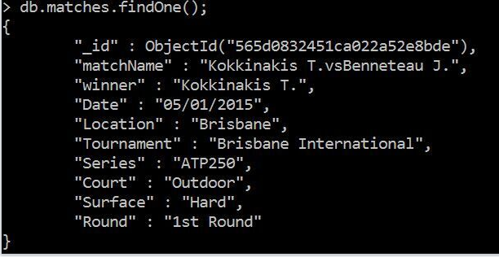

**8.2 Player Information**

The data for the player Information is generated using a php code.

This json is used to import into the MongoDB collection:PlayerInfo

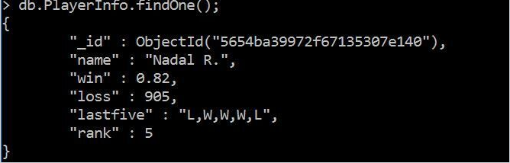

**8.3 Betting Trends**

**The number of bets placed in 11 different tennis betting websites and the bet money at any point in time are created using a java program.**



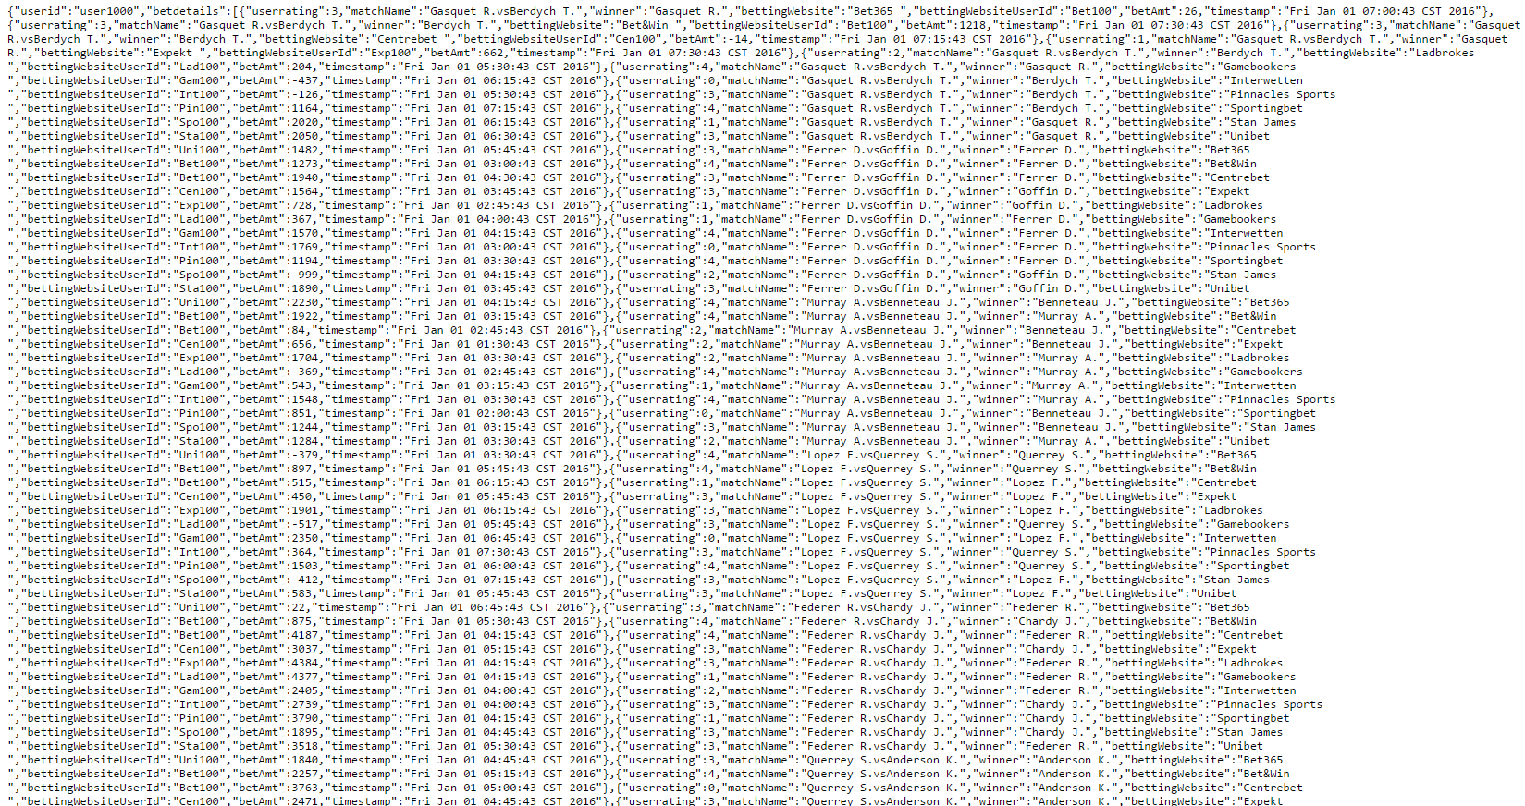

**The json file created by this java program is imported into the collection: user**

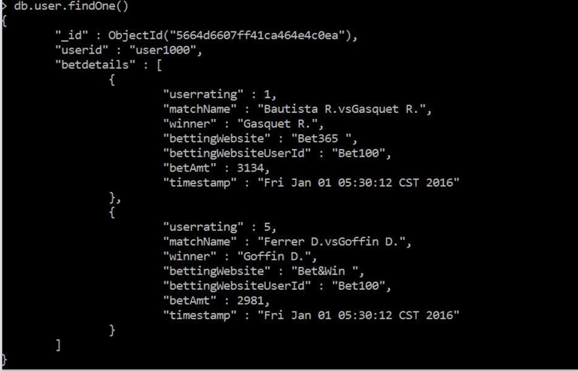

Fig: Single document for UserBettingdata

Every document has a userID and the betting details for the user

UserRating : The integer between 1 and 5 rated by the user for the particular website

MatchName: The match on which the user is betting

Winner: The probable winner for the user(The player on whom he is placing his bet)

Betting website : The particular website

BettingwebsiteUserID: The userID for the website

Timestamp: Time at which bet is placed

**8.4 Current Matches**

**The top current matches are saved in the database along with the match start time.**

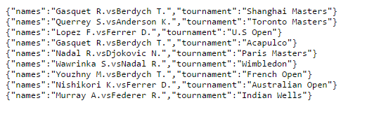

**This is used to create a collection in MongoDB :current Matches**

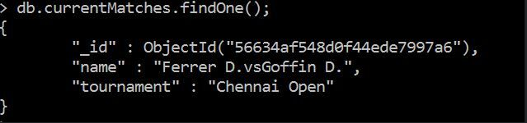

## **9. REFERENCES**

[**http://www.bloomberg.com/bw/articles/2014-01-23/data-loving-gamblers-bet-on-tennis-by-the-numbers**](http://www.bloomberg.com/bw/articles/2014-01-23/data-loving-gamblers-bet-on-tennis-by-the-numbers)

**http://www.sportsonearth.com/article/51670382/as-wimbledon-begins-does-tennis-have-a-gambling-problem**